AS Physics

Unit 1
Particles, Quantum Phenomena and Electricity
1 Constituents of the Atom
2 Particles and Antiparticles
3 Quarks
4 Hadrons
5 Leptons
6 Forces and Exchange Particles
7 The Strong Interaction
8 The Weak Interaction
9 Feynman Diagrams
10 The Photoelectric Effect
11 Excitation, Ionisation and Energy Levels
12 Wave Particle Duality
13 QVIRt
14 Ohm’s Law and I-V Graphs
15 Resistivity and Superconductivity
16 Series and Parallel Circuits
17 Energy and Power
18 EMF and Internal Resistance
19 Kirchhoff and Potential Dividers
20 Alternating Current
21 The Oscilloscope

Unit 1 | Constituents of the Atom
Lesson 1
Learning Outcomes | To be know the constituents of the atom with their masses and charges
Learning Outcomes | To be able to calculate the specific charge of the constituents
Learning Outcomes | To be able to explain what isotopes and ions are | N. DWYER

The Nuclear Model (Also seen in GCSE Physics 1 and 2)
Constituent | Charge (C) | Mass (kg)
Proton | 1.6 x 10⁻¹⁹ | 1.673 x 10⁻²⁷
Neutron | 0 | 1.675 x 10⁻²⁷
Electron | - 1.6 x 10⁻¹⁹ | 9.1 x 10⁻³¹
We know from Rutherford’s experiment that the structure of an atom consists of positively charged protons and neutral neutrons in one place called the nucleus. The nucleus sits in the middle of the atom and has negatively charged electrons orbiting it. At GCSE we used charges and masses for the constituents relative to each other, the table above shows the actual charges and masses.
Almost all of the mass of the atom is in the tiny nucleus which takes up practically no space when compared to the size of the atom. If we shrunk the Solar System so that the Sun was the size of a gold nucleus the furthest electron would be twice the distance to Pluto.
If the nucleus was a full stop it would be 25 m to the first electron shell, 100 to the second and 225 to the third.
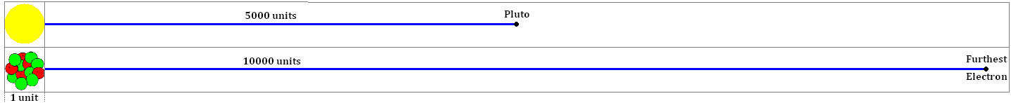

Notation (Also seen in GCSE Physics 2)
We can represent an atom of element X in the following way: ${}_{Z}^{A}{}X$
Z is the proton number. This is the number of protons in the nucleus. In an uncharged atom the number of electrons orbiting the nucleus is equal to the number of protons.
In Chemistry it is called the atomic number
A is the nucleon number. This is the total number of nucleons in the nucleus (protons + neutrons) which can be written as A = Z + N.
In Chemistry it is called the atomic mass number
N is the neutron number. This is the number of neutrons in the nucleus.

Isotopes (Also seen in GCSE Physics 1 and 2)
Isotopes are different forms of an element. They always have the same number of protons but have a different number of neutrons. Since they have the same number of protons (and electrons) they behave in the same way chemically.
Chlorine If we look at Chlorine in the periodic table we see that it is represented by ${}_{\text{17}}^{\text{35}\text{.}5}{}\text{Cl}$. How can it have 18.5 neutrons? It can’t! There are two stable isotopes of Chlorine, ${}_{\text{17}}^{\text{35}}{}\text{Cl}$which accounts for ~75% and ${}_{\text{17}}^{\text{37}}{}\text{Cl}$which accounts for ~25%. So the average of a large amount of Chlorine atoms is ${}_{\text{17}}^{\text{35}\text{.}5}{}\text{Cl}$.

Specific Charge
Specific charge is another title for the charge-mass ratio. This is a measure of the charge per unit mass and is simply worked out by worked out by dividing the charge of a particle by its mass.
You can think of it as a how much charge (in Coulombs) you get per kilogram of the ‘stuff’.
Constituent | Charge (C) | Mass (kg) | Charge-Mass Ratio (C kg⁻¹) or (C/kg)
Proton | 1.6 x 10⁻¹⁹ | 1.673 x 10⁻²⁷ | 1.6 x 10⁻¹⁹ ÷ 1.673 x 10⁻²⁷ | 9.58 x 10⁷
Neutron | 0 | 1.675 x 10⁻²⁷ | 0 ÷ 1.675 x 10⁻²⁷ | 0
Electron | (-) 1.6 x 10⁻¹⁹ | 9.1 x 10⁻³¹ | 1.6 x 10⁻¹⁹ ÷ 9.11 x 10⁻³¹ | (-) 1.76 x 10¹¹
We can see that the electron has the highest charge-mass ratio and the neutron has the lowest.

Ions (Also seen in GCSE Physics 2)
An atom may gain or lose electrons. When this happens the atoms becomes electrically charged (positively or negatively). We call this an ion.
If the atom gains an electron there are more negative charges than positive, so the atom is a negative ion.
Gaining one electron would mean it has an overall charge of -1, which actually means -1.6 x 10⁻¹⁹C.
Gaining two electrons would mean it has an overall charge of -2, which actually means -3.2 x 10⁻¹⁹C.
If the atom loses an electron there are more positive charges than negative, so the atom is a positive ion.
Losing one electron would mean it has an overall charge of +1, which actually means +1.6 x 10⁻¹⁹C.
Losing two electrons would mean it has an overall charge of +2, which actually means +3.2 x 10⁻¹⁹C.
Unit 1 | Particles and Antiparticles
Lesson 2
Learning Outcomes | To know what is the difference between particles and antiparticles
Learning Outcomes | To be able to explain what annihilation is
Learning Outcomes | To be able to explain what pair production is | N. DWYER

Antimatter
British Physicist Paul Dirac predicted a particle of equal mass to an electron but of opposite charge (positive). This particle is called a positron and is the electron’s antiparticle.
Every particles has its own antiparticle. An antiparticle has the same mass as the particle version but has opposite charge. An antiproton has a negative charge, an antielectron has a positive charge but an antineutron is also uncharged like the particle version.
American Physicist Carl Anderson observed the positron in a cloud chamber, backing up Dirac’s theory.
Anti particles have opposite Charge, Baryon Number, Lepton Number and Strangeness.
If they are made from quarks the antiparticle is made from antiquarks

Annihilation
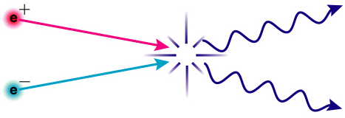
Whenever a particle and its antiparticle meet they annihilate each other. Annihilation is the process by which mass is converted into energy, particle and antiparticle are transformed into two photons of energy.
Mass and energy are interchangeable and can be converted from one to the other. Einstein linked energy and mass with the equation: $E={\text{mc}}^{2}$
You can think of it like money; whether you have dollars or pounds you would still have the same amount of money. So whether you have mass or energy you still have the same amount.
The law of conservation of energy can now be referred to as the conservation of mass-energy.
The total mass-energy before is equal to the total mass-energy after.

Photon
Max Planck had the idea that light could be released in ‘chunks’ or packets of energy. Einstein named these wave-packets photons. The energy carried by a photon is given by the equation:
$E=\text{hf}$ Since $c=fλ$ we can also write this as:$E=\frac{\text{hc}}{λ}$

How is there anything at all?
When the Big Bang happened matter and antimatter was produced and sent out expanding in all directions. A short time after this there was an imbalance in the amount of matter and antimatter. Since there was more matter all the antimatter was annihilated leaving matter to form protons, atoms and everything around us.

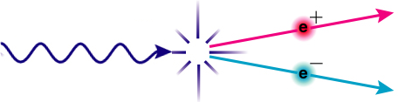
Pair Production
Pair production is the opposite process to annihilation, energy is converted into mass. A single photon of energy is converted into a particle-antiparticle pair. (This happens to obey the conservation laws)
This can only happen if the photon has enough mass-energy to “pay for the mass”.
Let us image mass and energy as the same thing, if two particles needed 10 “bits” and the photon had 8 bits there is not enough for pair production to occur.
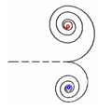
If two particles needed 10 bits to make and the photon had 16 bits the particle-antiparticle pair is made and the left over is converted into their kinetic energy.

If pair production occurs in a magnetic field the particle and antiparticle will move in circles of opposite direction but only if they are charged. (The deflection of charges in magnetic fields will be covered in Unit 4: Force on a Charged Particle)

Pair production can occur spontaneously but must occur near a nucleus which recoils to help conserve momentum. It can also be made to happen by colliding particles. At CERN protons are accelerated and fired into each other. If they have enough kinetic energy when they collide particle-antiparticle pair may be created from the energy.
The following are examples of the reactions that have occurred:
$p+p→p+p+p+\overline{p}$ $p+p→p+p+π^{+}+π^{−}$ $p+p→p+p+n+\overline{n}$
In all we can see that the conservation laws of particle physics are obeyed.
Unit 1 | Quarks
Lesson 3
Learning Outcomes | To know what quarks are and where they are found
Learning Outcomes | To be able to explain how they were discovered
Learning Outcomes | To know the properties of each type of quark | N. DWYER

Rutherford Also seen in GCSE Physics 2
Rutherford fired a beam of alpha particles at a thin gold foil. If the atom had no inner structure the alpha particles would only be deflected by very small angles. Some of the alpha particles were scattered at large angles by the nuclei of the atoms. From this Rutherford deduced that the atom was mostly empty space with the majority of the mass situated in the centre. Atoms were made from smaller particles.

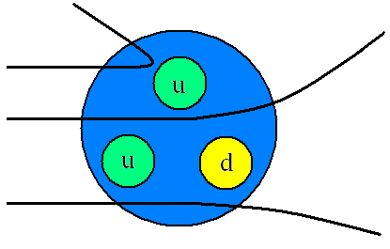
Smaller Scattering
In 1968 Physicists conducted a similar experiment to Rutherford’s but they fired a beam of high energy electrons at nucleons (protons and neutrons). The results they obtained were very similar to Rutherford’s; some of the electrons were deflected by large angles. If the nucleons had no inner structure the electrons would only be deflected by small angles. These results showed that protons and neutrons were made of three smaller particles, each with a fractional charge.

Quarks
These smaller particles were named quarks and are thought to be fundamental particles (not made of anything smaller). There are six different quarks and each one has its own antiparticle.
We need to know about the three below as we will be looking at how larger particles are made from different combinations of quarks and antiquarks.
Quark | Charge  (Q) | Baryon Number (B) | Strangeness  (S) |  | Anti Quark | Charge  (Q) | Baryon Number (B) | Strangeness  (S)
d | -⅓ | +⅓ | 0 |  | d̄ | +⅓ | -⅓ | 0
u | +⅔ | +⅓ | 0 |  | ū | -⅔ | -⅓ | 0
s | -⅓ | +⅓ | -1 |  | s̄ | +⅓ | -⅓ | +1

The other three are Charm, Bottom and Top. You will not be asked about these three
Quark | Charge | Baryon No. | Strangeness | Charmness | Bottomness | Topness
d | -⅓ | +⅓ | 0 | 0 | 0 | 0
u | +⅔ | +⅓ | 0 | 0 | 0 | 0
s | -⅓ | +⅓ | -1 | 0 | 0 | 0
c | +⅔ | +⅓ | 0 | +1 | 0 | 0
b | -⅓ | +⅓ | 0 | 0 | -1 | 0
t | +⅔ | +⅓ | 0 | 0 | 0 | +1

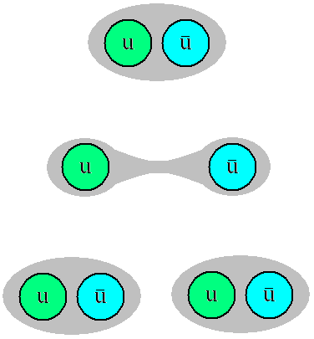
The Lone Quark?
Never! Quarks never appear on their own. The energy required to pull two quarks apart is so massive that it is enough to make two new particles. A quark and an antiquark are created, another example of pair production.
A particle called a neutral pion is made from an up quark and an antiup quark. Moving these apart creates another up quark and an antiup quark. We now have two pairs of quarks.
Trying to separate two quarks made two more quarks.

Particle Classification
Now that we know that quarks are the smallest building blocks we can separate all other particles into two groups, those made from quarks and those that aren’t made from quarks.
Hadrons – Heavy and made from smaller particles
Leptons – Light and not made from smaller particles
Unit 1 | Hadrons
Lesson 4
Learning Outcomes | To know what a hadron is and the difference between the two types
Learning Outcomes | To know the properties common to all hadrons
Learning Outcomes | To know the structure of the common hadrons and which is the most stable | N. DWYER

Made from Smaller Stuff
Hadrons, the Greek for ‘heavy’ are not fundamental particles they are all made from smaller particles, quarks.
The properties of a hadron are due to the combined properties of the quarks that it is made from.
There are two categories of Hadrons: Baryons and Mesons.

Baryons Made from three quarks
Proton | Charge  (Q) | Baryon Number (B) | Strangeness  (S) |  | Neutron | Charge  (Q) | Baryon Number (B) | Strangeness  (S)
u | +⅔ | +⅓ | 0 |  | d | -⅓ | +⅓ | 0
u | +⅔ | +⅓ | 0 |  | u | +⅔ | +⅓ | 0
d | -⅓ | +⅓ | 0 |  | d | -⅓ | +⅓ | 0
p | +1 | +1 | 0 |  | n | 0 | +1 | 0

The proton is the only stable hadron, all others eventually decay into a proton.

Mesons Made from a quark and an antiquark
Pion Plus | Charge  (Q) | Baryon Number (B) | Strangeness  (S) |  | Pion Minus | Charge  (Q) | Baryon Number (B) | Strangeness  (S)
u | +⅔ | +⅓ | 0 |  | ū | -⅔ | -⅓ | 0
d̄ | +⅓ | -⅓ | 0 |  | d | -⅓ | +⅓ | 0
π⁺ | +1 | 0 | 0 |  | π⁻ | -1 | 0 | 0

Pion Zero | Charge  (Q) | Baryon Number (B) | Strangeness  (S) |  | Pion Zero | Charge  (Q) | Baryon Number (B) | Strangeness  (S)
u | +⅔ | +⅓ | 0 |  | d | -⅓ | +⅓ | 0
ū | -⅔ | -⅓ | 0 |  | d̄ | +⅓ | -⅓ | 0
π⁰ | 0 | 0 | 0 |  | π⁰ | 0 | 0 | 0

Kaon Plus | Charge  (Q) | Baryon Number (B) | Strangeness  (S) |  | Kaon Minus | Charge  (Q) | Baryon Number (B) | Strangeness  (S)
u | +⅔ | +⅓ | 0 |  | ū | -⅔ | -⅓ | 0
s̄ | +⅓ | -⅓ | +1 |  | s | -⅓ | +⅓ | -1
K⁺ | +1 | 0 | +1 |  | K⁻ | -1 | 0 | -1

Kaon Zero | Charge  (Q) | Baryon Number (B) | Strangeness  (S) |  | AntiKaon  Zero | Charge  (Q) | Baryon Number (B) | Strangeness  (S)
d | -⅓ | +⅓ | 0 |  | d̄ | +⅓ | -⅓ | 0
s̄ | +⅓ | -⅓ | +1 |  | s | -⅓ | +⅓ | -1
K⁰ | 0 | 0 | +1 |  | K̄⁰ | 0 | 0 | -1

Anti Hadrons
Anti hadrons are made from the opposite quarks as their Hadron counterparts, for example a proton is made from the quark combination uud and an antiproton is made from the combination ūūd̄
We can see that a π⁺ and a π⁻ are particle and antiparticle of each other.
Anti Proton | Charge  (Q) | Baryon Number (B) | Strangeness  (S) |  | Anti  Neutron | Charge  (Q) | Baryon Number (B) | Strangeness  (S)
ū | -⅔ | -⅓ | 0 |  | d̄ | +⅓ | -⅓ | 0
ū | -⅔ | -⅓ | 0 |  | ū | -⅔ | -⅓ | 0
d̄ | +⅓ | -⅓ | 0 |  | d̄ | +⅓ | -⅓ | 0
p̄̄ | -1 | -1 | 0 |  | n̄ | 0 | -1 | 0
You need to know all the quark combination shown on this page as they may ask you to recite any of them.
Unit 1 | Leptons
Lesson 5
Learning Outcomes | To be able to explain what a lepton is
Learning Outcomes | To know the properties common to all leptons
Learning Outcomes | To be able to explain the conservation laws and be able to use them | N. DWYER

Fundamental Particles
A fundamental particle is a particle which is not made of anything smaller. Baryons and Mesons are made from quarks so they are not fundamental, but quarks themselves are. The only other known fundamental particles are Bosons (see Lesson 6: Forces and Exchange Particles) and Leptons.

Leptons
Leptons are a family of particles that are much lighter than Baryons and Mesons and are not subject to the strong interaction. There are six leptons in total, three of them are charged and three are uncharged.
The charged particles are electrons, muons and tauons. The muon and tauon are similar to the electron but bigger. The muon is roughly 200 times bigger and the tauon is 3500 times bigger (twice the size of a proton).
Each of the charged leptons has its own neutrino. If a decay involves a neutrino and a muon, it will be a muon neutrino, not a tauon neutrino or electron neutrino.
The neutrino is a chargeless, almost massless particle. It isn’t affected by the strong interaction or EM force and barely by gravity. It is almost impossible to detect.

Lepton |  | Charge  (Q) | Lepton Number (L) |  | Anti Lepton |  | Charge  (Q) | Lepton Number (L)
Electron | e⁻ | -1 | +1 |  | Anti Electron | e⁺ | +1 | -1
Electron Neutrino | ν_{e} | 0 | +1 |  | Anti Electron Neutrino | ν̄_{e} | 0 | -1
Muon | μ⁻ | -1 | +1 |  | Anti Muon | μ⁺ | +1 | -1
Muon Neutrino | ν_{μ} | 0 | +1 |  | Anti Muon Neutrino | ν̄_{μ} | 0 | -1
Tauon | τ⁻ | -1 | +1 |  | Anti Tauon | τ⁺ | +1 | -1
Tauon Neutrino | ν_{τ} | 0 | +1 |  | Anti Tauon Neutrino | ν̄_{τ} | 0 | -1

Conservation Laws
For a particle interaction to occur the following laws must be obeyed, if either is violated the reaction will never be observed (will never happen):
Charge: Must be conserved (same total value before as the total value after)
Baryon Number: Must be conserved
Lepton Number: Must be conserved
Strangeness: Conserved in EM and Strong Interaction. Doesn’t have to be conserved in Weak Interaction

Examples
In pair production a photon of energy is converted into a particle and its antiparticle
 | γ | → | e⁻ | + | e⁺
Q | 0 | → | -1 | + | +1 | 0 | → | 0 | Conserved
B | 0 | → | 0 | + | 0 | 0 | → | 0 | Conserved
L | 0 | → | +1 | + | -1 | 0 | → | 0 | Conserved
S | 0 | → | 0 | + | 0 | 0 | → | 0 | Conserved
Let us look at beta plus decay as we knew it at GCSE. A neutron decays into a proton and releases an electron.
 | n | → | p | + | e⁻
Q | 0 | → | +1 | + | -1 | 0 | → | 0 | Conserved
B | +1 | → | +1 | + | 0 | +1 | → | +1 | Conserved
L | 0 | → | 0 | + | +1 | 0 | → | +1 | Not Conserved
S | 0 | → | 0 | + | 0 | 0 | → | 0 | Conserved
This contributed to the search for and discovery of the neutrino.
Number Reminders
There may be a clue to the charge of a particle; π⁺, K⁺ and e⁺ have a positive charge.
It will only have a baryon number if it IS a baryon. Mesons and Leptons have a Baryon Number of zero.
It will only have a lepton number if it IS a lepton. Baryons and Mesons have a Lepton Number of zero.
It will only have a strangeness if it is made from a strange quark. Leptons have a strangeness of zero.
Unit 1 | Forces and Exchange Particles
Lesson 6
Learning Outcomes | To know the four fundamental forces, their ranges and relative strengths
Learning Outcomes | To know what each force does and what it acts on
Learning Outcomes | To be able to explain what exchange particles are | N. DWYER

The Four Interactions
There are four forces in the universe, some you will have come across already and some will be new:
The electromagnetic interaction causes an attractive or repulsive force between charges.
The gravitational interaction causes an attractive force between masses.
The strong nuclear interaction causes an attractive (or repulsive) force between quarks (and so hadrons).
The weak nuclear interaction does not cause a physical force, it makes particles decay. ‘Weak’ means there is a low probability that it will happen.
Interaction/Force | Range | Relative Strength
Strong Nuclear | ~10⁻¹⁵m | 1 | (1)
Electromagnetic | ∞ | ~10^{–2} | (0.01)
Weak Nuclear | ~10⁻¹⁸m | ~10^{–7} | (0.0000001)
Gravitational | ∞ | ~10^{–36} | (0.000000000000000000000000000000000001)

Exchange Particles
In 1935 Japanese physicist Hideki Yukawa put forward the idea that the interactions/forces between two particles were caused by ‘virtual particles’ being exchanged between the two particles.
He was working on the strong nuclear force which keeps protons and neutrons together and theorised that they were exchanging a particle back and forth that ‘carried’ the force and kept them together. This is true of all the fundamental interactions.
The general term for exchange particles is bosons and they are fundamental particles like quarks and leptons.

Ice Skating Analogy
Imagine two people on ice skates that will represent the two bodies experiencing a force.
If A throws a bowling ball to B, A slides back when they release it and B moves back when they catch it. Repeatedly throwing the ball back and forth moves A and B away from each other, the force causes repulsion.
The analogy falls a little short when thinking of attraction, but bear with it.
Now imagine that A and B are exchanging a boomerang (bear with it), throwing it behind them pushes A towards B, B catches it from behind and moves towards A. The force causes attraction.

Which Particle for What Force
Each of the interactions/forces has its own exchange particles.
Interaction/Force | Exchange Particle |  |  |  | What is acts upon
Strong Nuclear | Gluons between quarks |  | Pions between Baryons |  | Nucleons (Hadrons)
Electromagnetic | Virtual Photon |  |  |  | Charged particles
Weak Nuclear | W⁺ | W– |  | Z⁰ | All particles
Gravitational | Graviton |  |  |  | Particles with masses

Borrowing Energy to Make Particles
The exchange particles are made from ‘borrowed’ energy, borrowed from where? From nowhere! Yukawa used the Heisenberg Uncertainty Principle to establish that a particle of mass-energy ΔE could exist for a time Δt as long as $ΔE\text{.}Δt≤h$ where h is Planck’s constant. This means that a heavy particle can only exist for a short time while a lighter particle may exist for longer.
h is Planck’s Constant, h = 6.63 x 10⁻³⁴ J s.
In 1947 the exchange particle of the strong nuclear interaction were observed in a cloud chamber.

Lending Money Analogy
Think of making exchange particles in terms of lending somebody some money.
If you lend somebody £50 you would want it paid back fairly soon.
If you lend somebody 50p you would let them have it for longer before paying you back.
Unit 1 | The Strong Interaction
Lesson 7
Learning Outcomes | To know why a nucleus doesn’t tear itself apart
Learning Outcomes | To know why a nucleus doesn’t collapse in on itself
Learning Outcomes | To know why the neutron exists in the nucleus | N. DWYER

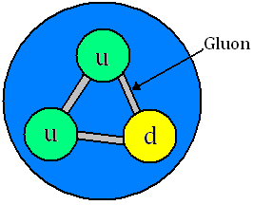
The Strong Interaction
The strong nuclear force acts between quarks. Since Hadrons are the only particles made of quarks only they experience the strong nuclear force.
In both Baryons and Mesons the quarks are attracted to each other by exchanging virtual particles called ‘gluons’.
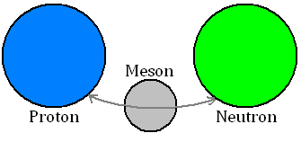
On a larger scale the strong nuclear force acts between the Hadrons themselves, keeping them together. A pi-meson or pion (π) is exchanged between the hadrons. This is called the residual strong nuclear force.

Force Graphs
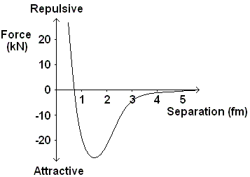
Neutron-Neutron or Neutron-Proton
Here is the graph of how the force varies between two neutrons or a proton and a neutron as the distance between them is increased.
We can see that the force is very strongly repulsive at separations of less than 0.7 fm ( x 10^{–15} m). This prevents all the nucleons from crushing into each other.
Above this separation the force is strongly attractive with a peak around 1.3 fm. When the nucleons are separated by more than 5 fm they no longer experience the SNF.
Proton-Proton
The force-separation graphs for two protons is different. They both attract each other due to the SNF but they also repel each other due to the electromagnetic force which causes two like charges to repel.
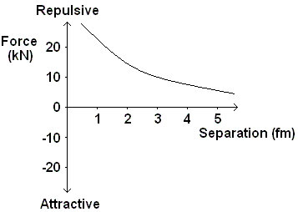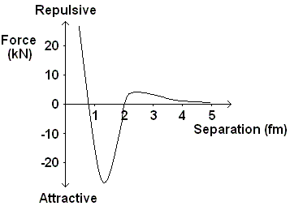
Graph A Graph B Graph C
Graph A shows how the strong nuclear force varies with the separation of the protons
Graph B shows how the electromagnetic force varies with the separation of the protons
Graph C shows the resultant of these two forces: repulsive at separations less than 0.7 fm, attractive up to 2 fm when the force becomes repulsive again.

Neutrons – Nuclear Cement
In the lighter elements the number of protons and neutrons in the nucleus is the same. As the nucleus gets bigger more neutrons are needed to keep it together.
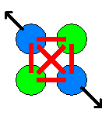
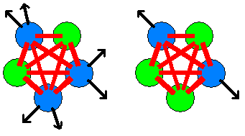
Adding another proton means that all the other nucleons feel the SNF attraction. It also means that all the other protons feel the EM repulsion.

Adding another neutron adds to the SNF attraction between the nucleons but, since it is uncharged, it does not contribute to the EM repulsion.
Unit 1 | The Weak Interaction
Lesson 8
Learning Outcomes | To be able to write the equation for alpha and beta decay
Learning Outcomes | To know what a neutrino is and why is must exist
Learning Outcomes | To be able to state the changes in quarks during beta plus and beta minus decay | N. DWYER

Alpha Decay
When a nucleus decays in this way an alpha particle (a helium nucleus) is ejected from the nucleus.
${}_{Z}^{A}{}X→{}_{Z−2}^{A−4}{}Y+{}_{2}^{4}{}α$ or ${}_{Z}^{A}{}X→{}_{Z−2}^{A−4}{}Y+{}_{2}^{4}{}\text{He}$
All the emitted alpha particles travelled at the same speed, meaning they had the same amount of energy. The law of conservation of mass-energy is met, the energy of the nucleus before the decay is the same as the energy of the nucleus and alpha particle after the decay.
Alpha decay is NOT due to the weak interaction but Beta decay IS

Beta Decay and the Neutrino
In beta decay a neutron in the nucleus changes to a proton and releases a beta particle (an electron).
The problem with beta decay was that the electrons had a range of energies so the law of conservation of mass-energy is violated, energy disappears. There must be another particle being made with zero mass but variable speeds, the neutrino.
We can also see from the particle conservation laws that this is a forbidden interaction: $n→p+e^{−}$
Charge Q: 0$→$+1–1 0$→$0 Charge is conserved
Baryon Number B: +1$→$+1+0 1$→$1 Baryon number is conserved
Lepton Number L: 0$→$0+1 0$→$1 Lepton number is NOT conserved

Beta Minus (β–) Decay
In neutron rich nuclei a neutron may decay into a proton, electron and an anti electron neutrino.
$$n→p+e^{−}+\overline{ν_{e}}$$
Charge Q: 0$→$+1–1+0 0$→$0 Charge is conserved
Baryon Number B: +1$→$+1+0+0 1$→$1 Baryon number is conserved
Lepton Number L: 0$→$0+1–1 0$→$0 Lepton number is conserved

In terms of quarks beta minus decay looks like this: $\text{dud}→\text{uud}+e^{−}+\overline{ν_{e}}$ which simplifies to:
$$d→u+e^{−}+\overline{ν_{e}}$$
Charge Q: – ⅓$→$+⅔–1+0 – ⅓$→$– ⅓ Charge is conserved
Baryon Number B: +⅓$→$+⅓+0+0 ⅓$→$⅓ Baryon number is conserved
Lepton Number L: 0$→$0+1–1 0$→$0 Lepton number is conserved

Beta Plus (β⁺) Decay
In proton rich nuclei a proton may decay into a neutron, positron and an electron neutrino.
$$p→n+e^{+}+ν_{e}$$
Charge Q: +1$→$0+1+0 1$→$1 Charge is conserved
Baryon Number B: +1$→$+1+0+0 1$→$1 Baryon number is conserved
Lepton Number L: 0$→$0–1+1 0$→$0 Lepton number is conserved

In terms of quarks beta plus decay looks like this: $\text{uud}→\text{dud}+e^{+}+ν_{e}$ which simplifies to:
$$u→d+e^{+}+ν_{e}$$
Charge Q: +⅔$→$–⅓+1+0 ⅔$→$⅔ Charge is conserved
Baryon Number B: +⅓$→$+⅓+0+0 ⅓$→$⅓ Baryon number is conserved
Lepton Number L: 0$→$0–1+1 0$→$0 Lepton number is conserved

Strangeness
The weak interaction is the only interaction that causes a quark to change into a different type of quark. In beta decay up quarks and down quarks are changed into one another. In some reactions an up or down quark can change into a strange quark meaning strangeness is not conserved.
During the weak interaction there can be a change in strangeness of ±1.
Unit 1 | Feynman Diagrams
Lesson 9
Learning Outcomes | To know what a Feynman diagram shows us
Learning Outcomes | To be able to draw Feynman diagrams to represent interactions and decays
Learning Outcomes | To be able to state the correct exchange particle | N. DWYER

Feynman Diagrams
An American Physicist called Richard Feynman came up with a way of visualising forces and exchange particles. Below are some examples of how Feynman diagrams can represent particle interactions.
The most important things to note when dealing with Feynman diagrams are the arrows and the exchange particles, the lines do not show us the path that the particles take only which come in and which go out.
The arrows tell us which particles are present before the interaction and which are present after the interaction.
The wave represents the interaction taking place with the appropriate exchange particle labelled.

Examples
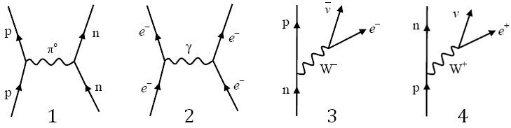
Diagram 1 represents the strong interaction. A proton and neutron are attracted together by the exchange of a neutral pion.
Diagram 2 represents the electromagnetic interaction. Two electrons repel each other by the exchange of a virtual photon.
Diagram 3 represents beta minus decay. A neutron decays due to the weak interaction into a proton, an electron and an anti electron neutrino
Diagram 4 represents beta plus decay. A proton decays into a neutron, a positron and an electron neutrino.
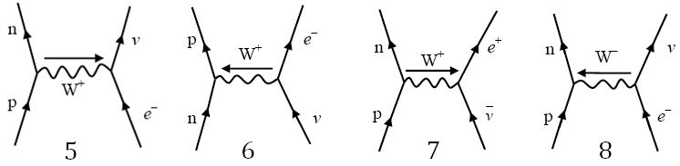
Diagram 5 represents electron capture. A proton captures an electron and becomes a neutron and an electron neutrino.
Diagram 6 represents a neutrino-neutron collision. A neutron absorbs a neutrino and forms a proton and an electron.
Diagram 7 represents an antineutrino-proton collision. A proton absorbs an antineutrino and emits a neutron and an electron.
Diagram 8 represents an electron-proton collision. They collide and emit a neutron and an electron neutrino.

Getting the Exchange Particle
The aspect of Feynman diagrams that students often struggle with is labelling the exchange particle and the direction to draw it. Look at what you start with:
If it is positive and becomes neutral you can think of it as throwing away its positive charge so the boson will be positive. This is the case in electron capture.
If it is positive and becomes neutral you can think of it as gaining negative to neutralise it so the boson will be negative. This is the case in electron-proton collisions.
If it is neutral and becomes positive we can think of it either as gaining positive (W+ boson) or losing negative (W– boson in the opposite direction).
Work out where the charge is going and label it.
Unit 1 | The Photoelectric Effect
Lesson 10
Learning Outcomes | To know what the photoelectric effect is and how frequency and intensity affect it
Learning Outcomes | To be able to explain what photon, photoelectron, work function and threshold frequency are
Learning Outcomes | To be able to calculate the kinetic energy of a photoelectron | N. DWYER

Observations
When light fell onto a metal plate it released electrons from the surface straight away. Increasing the intensity increased the number of electrons emitted. If the frequency of the light was lowered, no electrons were emitted at all. Increasing the intensity and giving it more time did nothing, no electrons were emitted.

If Light was a Wave…
Increasing the intensity would increase the energy of the light. The energy from the light would be evenly spread over the metal and each electron would be given a small amount of energy. Eventually the electron would have enough energy to be removed from the metal.

Photon
Max Planck had the idea that light could be released in ‘chunks’ or packets of energy. Einstein named these wave-packets photons. The energy carried by a photon is given by the equation:
$E=\text{hf}$ Since $c=fλ$ we can also write this as:$E=\frac{\text{hc}}{λ}$

Explaining the Photoelectric Effect
Einstein suggested that one photon collides with one electron in the metal, giving it enough energy to be removed from the metal and then fly off somewhere. Some of the energy of the photon is used to break the bonds holding the electron in the metal and the rest of the energy is used by the electron to move away (kinetic energy). He represented this with the equation: $\text{hf}=φ+E_{K}$
hf represents the energy of the photon, φ is the work function and E_{K} is the kinetic energy.

Work Function, φ
The work function is the amount of energy the electron requires to be completely removed from the surface of the metal. This is the energy just to remove it, not to move away.

Threshold Frequency, f₀
The threshold frequency is the minimum frequency that would release an electron from the surface of a metal, any less and nothing will happen.
Since $\text{hf}=φ+E_{K}$, the minimum frequency releases an electron that is not moving, so E_{K} = 0
${\text{hf}}_{0}=φ$ which can be rearranged to give: $f_{0}=\frac{φ}{h}$
Increasing the intensity increases the number of photons the light sources gives out each second.
If the photon has less energy than the work function an electron can not be removed. Increasing the intensity just sends out more photons, all of which would still not have enough energy to release an electron.

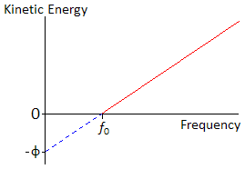
Graph
If we plot a graph of the kinetic energy of the electrons against frequency we get a graph that looks like this:
Start with $\text{hf}=φ+E_{K}$ and transform into $y=\text{mx}+c$.
E_{K} is the y-axis and f is the x- axis.
This makes the equation become: $E_{K}=\text{hf}−φ$
So the gradient represents Planck’s constant
and the y-intercept represents (–) the work function.

Nightclub Analogy
We can think of the photoelectric effect in terms of a full nightclub; let the people going into the club represent the photons, the people leaving the club represent the electrons and money represent the energy.
The club is full so it is one in and one out. The work function equals the entrance fee and is £5:
If you have £3 you don’t have enough to get in so noone is kicked out.
If 50 people arrive with £3 no one has enough, so one gets in and noone is kicked out.
If you have £5 you have enough to get in so someone is kicked out, but you have no money for booze.
If 50 people arrive with £5 you all get in so 50 people are kicked out, but you have no money for booze.
If you have £20 you have enough to get in so someone is kicked out and you have £15 to spend on booze.
If 50 people arrive with £20 you all get in so 50 people are kicked out and you have £15 each to spend on booze.
Unit 1 | Excitation, Ionisation and Energy Levels
Lesson 11
Learning Outcomes | To know how Bohr solved the falling electron problem
Learning Outcomes | To be able to explain what excitation, de-excitation and ionisation are
Learning Outcomes | To be able to calculate the frequency needed for excitation to a certain level | N. DWYER

The Electronvolt, eV
The Joule is too big use on an atomic and nuclear scale so we will now use the electronvolt, represented by eV.
One electronvolt is equal to the energy gained by an electron of charge e, when it is accelerated through a potential difference of 1 volt. 1eV = 1.6 x 10⁻¹⁹J 1J = 6.25 x 10¹⁸eV
eV → J multiply by e J → eV divide by e

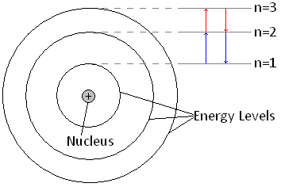
The Problem with Atoms
Rutherford’s nuclear model of the atom leaves us with a problem: a charged particle emits radiation when it accelerates. This would mean that the electrons would fall into the nucleus.

Bohr to the Rescue
Niels Bohr solved this problem by suggesting that the electrons could only orbit the nucleus in certain ‘allowed’ energy levels. He suggested that an electron may only transfer energy when it moves from one energy level to another. A change from one level to another is called a ‘transition’.
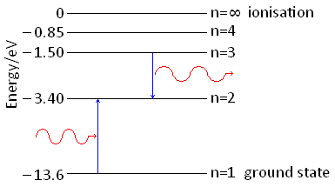
To move up and energy level the electron must gain the exact amount of energy to make the transition.
It can do this by another electron colliding with it or by absorbing a photon of the exact energy.
When moving down a level the electron must lose the exact amount of energy when making the transition.
It releases this energy as a photon of energy equal to the energy it loses.
$$ΔE=\text{hf}=E_{1}−E_{2}$$
E₁ is the energy of the level the electron starts at and E₂ is the energy of the level the electron ends at

Excitation
When an electron gains the exact amount of energy to move up one or more energy levels

De-excitation
When an electron gives out the exact amount of energy to move back down to its original energy level

Ionisation
An electron can gain enough energy to be completely removed from the atom.
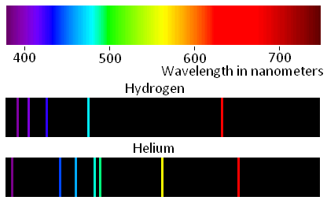
The ground state and the energy levels leading up to ionisation have negative values of energy, this is because they are compared to the ionisation level. Remember that energy must be given to the electrons to move up a level and is lost (or given out) when it moves down a level.

Line Spectra
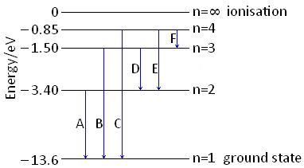
Atoms of the same element have same energy levels. Each transition releases a photon with a set amount of energy meaning the frequency and wavelength are also set. The wavelength of light is responsible for colour it is. We can analyse the light by using a diffraction grating to separate light into the colours that makes it up, called its line spectra. Each element has its own line spectra like a barcode.
To the above right are the line spectra of Hydrogen and Helium.
We can calculate the energy difference that created the colour.
If we know the energy differences for each element we can work out which element is responsible for the light and hence deduce which elements are present.
We can see that there are 6 possible transitions in the diagram to the left, A to F.
D has an energy difference of 1.9 eV or 3.04 x 10⁻¹⁹ J which corresponds to a frequency of 4.59 x 10¹⁴ Hz and a wavelength of 654 nm – red.
Unit 1 | Wave-Particle Duality
Lesson 12
Learning Outcomes | To know how to calculate the de Broglie wavelength and what is it
Learning Outcomes | To be able to explain what electron diffraction shows us
Learning Outcomes | To know what wave-particle duality is | N. DWYER

De Broglie
In 1923 Louis de Broglie put forward the idea that ‘all particles have a wave nature’ meaning that particles can behave like waves.
This doesn’t sound too far fetched after Einstein proved that a wave can behave like a particle.
De Broglie said that all particles could have a wavelength. A particle of mass, m, that is travelling at velocity, v, would have a wavelength given by:
$λ=\frac{h}{\text{mv}}$ which is sometime written as $λ=\frac{h}{p}$ where p is momentum
This wavelength is called the de Broglie wavelength. The modern view is that the de Broglie wavelength is linked to the probability of finding the particle at a certain point in space.
De Broglie wavelength is measured in metres, m

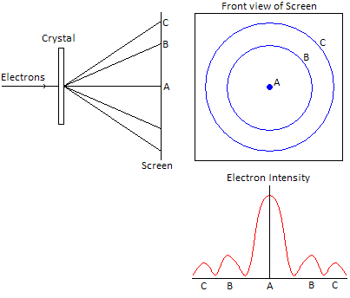
Electron Diffraction
Two years after de Broglie came up with his particle wavelengths and idea that electrons could diffract, Davisson and Germer proved this to happen.
They fired electrons into a crystal structure which acted as a diffraction grating. This produced areas of electrons and no electrons on the screen behind it, just like the pattern you get when light diffracts.

Electron Wavelength
We can calculate the de Broglie wavelength of an electron from the potential difference, V, that accelerated it.
Change in electric potential energy gained = eV
This is equal to the kinetic energy of the electron $\text{eV}=\frac{1}{2}{\text{mv}}^{2}$
The velocity is therefore given by: $\sqrt{\frac{2\text{eV}}{m}}=v$
We can substitute this into $λ=\frac{h}{\text{mv}}$ to get: $λ=\frac{h}{\sqrt{2\text{meV}}}$

Sand Analogy
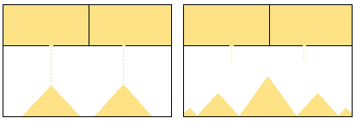
If we compare a double slit electron diffraction to sand falling from containers we can see how crazy electron diffraction is. Imagine two holes about 30cm apart that sand is dropping from. We would expect to find a maximum amount of sand under each hole, right? This is not what we find! We find a maximum in between the two holes. The electrons are acting like a wave.

Wave-Particle Duality
Wave-particle duality means that waves sometimes behave like particles and particles sometimes behave like waves. Some examples of these are shown below:

Light as a Wave
Diffraction, interference, polarisation and refraction all prove that light is a wave and will be covered in Unit 2.

Light as a Particle
We have seen that the photoelectric effect shows that light can behave as a particle called a photon.

Electron as a Particle
The deflection by an electromagnetic field and collisions with other particles show its particle nature.

Electron as a Wave
Electron diffraction proves that a particle can show wave behaviour .
Unit 1 | QVIRt
Lesson 13
Learning Outcomes | To be able to explain what current, charge, voltage/potential difference and resistance are
Learning Outcomes | To know the equations that link these
Learning Outcomes | To know the correct units to be use in each | N. DWYER

Definitions (Also seen in GCSE Physics 2)

Current, I
Electrical current is the rate of flow of charge in a circuit. Electrons are charged particles that move around the circuit. So we can think of the electrical current is the rate of the flow of electrons, not so much the speed but the number of electrons moving in the circuit. If we imagine that electrons are Year 7 students and a wire of a circuit is a corridor, the current is how many students passing in a set time.
Current is measured in Amperes (or Amps), A

Charge, Q
The amount of electrical charge is a fundamental unit, similar to mass and length and time. From the data sheet we can see that the charge on one electron is actually -1.60 x 10⁻¹⁹ C. This means that it takes 6.25 x 10¹⁸ electrons to transfer 1C of charge.
Charge is measured in Coulombs, C

Voltage/Potential Difference, V
Voltage, or potential difference, is the work done per unit charge.
1 unit of charge is 6.25 x 10¹⁸ electrons, so we can think of potential difference as the energy given to each of the electrons, or the pushing force on the electrons. It is the p.d. that causes a current to flow and we can think of it like water flowing in a pipe. If we make one end higher than the other end, water will flow down in, if we increase the height (increase the p.d.) we get more flowing. If we think of current as Year 7s walking down a corridor, the harder we push them down the corridor the more we get flowing.
Voltage and p.d. are measured in Volts, V

Resistance, R
The resistance of a material tells us how easy or difficult it is to make a current flow through it. If we think of current as Year 7s walking down a corridor, it would be harder to make the Year 7s flow if we added some Year 11 rugby players into the corridor. Increasing resistance lowers the current.
Resistance is measured in Ohms, Ω
Time, t
You know, time! How long stuff takes and that.
Time is measured in seconds, s
Equations
There are three equations that we need to be able to explain and substitute numbers into.
1
$I=\frac{ΔQ}{Δt}$
This says that the current is the rate of change of charge per second and backs up or idea of current as the rate at which electrons (and charge) flow.
This can be rearranged into
$$ΔQ=IΔt$$
which means that the charge is equal to how much is flowing multiplied by how long it flows for.

2
$$V=\frac{E}{Q}$$
This says that the voltage/p.d. is equal to the energy per charge. The ‘push’ of the electrons is equal to the energy given to each charge (electron).

3
$$V=\text{IR}$$
This says that increasing the p.d. increases the current. Increasing the ‘push’ of the electrons makes more flow.
It also shows us that for constant V, if R increases I gets smaller. Pushing the same strength, if there is more blocking force less current will flow.
Unit 1 | Ohm’s Laws and I-V Graphs
Lesson 14
Learning Outcomes | To be able to sketch and explain the I-V graphs of a diode, filament lamp and resistor
Learning Outcomes | To be able to describe the experimental set up and measurements required to obtain these graphs
Learning Outcomes | To know how the resistance of an LDR and Thermistor varies | N. DWYER

Ohm’s Law (Also seen in GCSE Physics 2)
After the last lesson we knew that a voltage (or potential difference) causes a current to flow and that the size of the current depends on the size of the p.d.
For something to obey Ohm’s law the current flowing is proportional to the p.d. pushing it. V=IR so this means the resistance is constant. On a graph of current against p.d. this appears as a straight line.

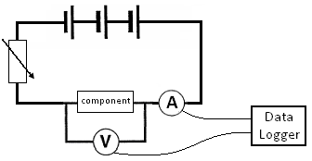
Taking Measurements
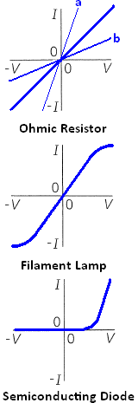
To find how the current through a component varies with the potential difference across it we must take readings. To measure the potential difference we use a voltmeter connected in parallel and to measure the current we use an ammeter connected in series.
If we connect the component to a battery we would now have one reading for the p.d. and one for the current. But what we require is a range of readings. One way around this would be to use a range of batteries to give different p.d.s. A better way is to add a variable resistor to the circuit, this allows us to use one battery and get a range of readings for current and p.d. To obtain values for current in the negative direction we can reverse either the battery or the component.

I-V Graphs (Also seen in GCSE Physics 2)
Resistor
This shows that when p.d. is zero so is the current. When we increase the p.d. in one direction the current increases in that direction. If we apply a p.d. in the reverse direction a current flows in the reverse direction. The straight line shows that current is proportional to p.d. and it obeys Ohm’s law. Graph a has a lower resistance than graph b because for the same p.d. less current flows through b.

Filament Lamp
At low values the current is proportional to p.d. and so, obeys Ohm’s law.
As the potential difference and current increase so does the temperature. This increases the resistance and the graph curves, since resistance changes it no longer obeys Ohm’s law.

Diode
This shows us that in one direction increasing the p.d. increases the current but in the reverse direction the p.d. does not make a current flow. We say that it is forward biased. Since resistance changes it does not obey Ohm’s law.

Three Special Resistors (Also seen in GCSE Physics 2)
Variable Resistor
A variable resistor is a resistor whose value can be changed.
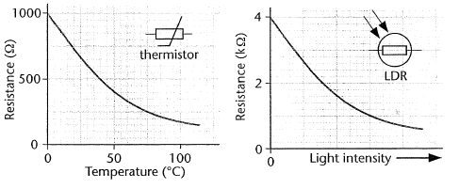
Thermistor
The resistance of a thermistor varied with temperature. At low temperatures the resistance is high, at high temperatures the resistance is low.

Light Dependant Resistor (L.D.R)
The resistance of a thermistor varied with light intensity. In dim light the resistance is high and in bright light the resistance is low.
Unit 1 | Resistivity and Superconductivity
Lesson 15
Learning Outcomes | To be able to state what affects resistance of a wire and explain how they affect it
Learning Outcomes | To be able to describe the experimental set up required to calculate resistivity and define it
Learning Outcomes | To be able to explain superconductivity and state its uses | N. DWYER

Resistance
The resistance of a wire is caused by free electrons colliding with the positive ions that make up the structure of the metal. The resistance depends upon several factors:
Length, l Length increases – resistance increases
The longer the piece of wire the more collisions the electrons will have.
Area, A Area increases – resistance decreases
The wider the piece of wire the more gaps there are between the ions.
Temperature Temperature increases – resistance increases
As temperature increases the ions are given more energy and vibrate more, the electrons are more likely to collide with the ions.
Material
The structure of any two metals is similar but not the same, some metal ions are closer together, others have bigger ions.

Resistivity, ρ
The resistance of a material can be calculate using $R=ρ\frac{l}{A}$ where ρ is the resistivity of the material.
Resistivity is a factor that accounts for the structure of the metal and the temperature. Each metal has its own value of resisitivity for each temperature. For example, the resistivity of copper is 1.7x10⁻⁸ Ωm and carbon is 3x10⁻⁵ Ωm at room temperature. When both are heated to 100°C their resistivities increase.
Resistivity is measured in Ohm metres , Ωm

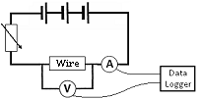Measuring Resistivity
In order to measure resistivity of a wire we need to measure the length, cross-sectional area (using Area = πr²) and resistance.
Remember, to measure the resistance we need to measure values of current and potential difference using the set up shown on the right
We then rearrange the equation to $ρ=\frac{\text{RA}}{l}$ and substitute values in

Superconductivity
The resistivity (and so resistance) of metals increases with the temperature. The reverse is also true that, lowering the temperature lowers the resistivity.
When certain metals are cooled below a critical temperature their resistivity drops to zero. The metal now has zero resistance and allows massive currents to flow without losing any energy as heat. These metals are called superconductors. When a superconductor is heated above it’s critical temperature it loses its superconductivity and behaves like other metals.
The highest recorded temperature to date is –196°C, large amounts of energy are required to cool the metal to below this temperature.

Uses of Superconductors
High-power electromagnets
Power cables
Magnetic Resonance Imaging (MRI) scanners
Unit 1 | Series and Parallel Circuits
Lesson 16
Learning Outcomes | To be able to calculate total current in series and parallel circuits
Learning Outcomes | To be able to calculate total potential difference in series and parallel circuits
Learning Outcomes | To be able to calculate total resistance in series and parallel circuits | N. DWYER
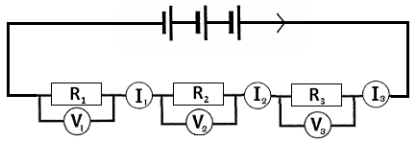

Series Circuits (Also seen in GCSE Physics 2)
In a series circuit all the components are in one circuit or loop. If resistor 1 in the diagram was removed this would break the whole circuit.

The total current of the circuit is the same at each point in the circuit. $I_{\text{TOTAL}}=I_{1}=I_{2}=I_{3}$
The total voltage of the circuit is equal to the sum of the p.d.s across each resistor. $V_{\text{TOTAL}}=V_{1}+V_{2}+V_{3}$
The total resistance of the circuit is equal to the sum of the resistance of each resistor. $R_{\text{TOTAL}}=R_{1}+R_{2}+R_{3}$
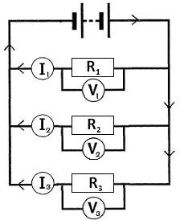
Parallel Circuits (Also seen in GCSE Physics 2)
Components in parallel have their own separate circuit or loop. If resistor 1 in the diagram was removed this would only break that circuit, a current would still flow through resistors 2 and 3.

The total current is equal to the sum of the currents through each resistor.
$$I_{\text{TOTAL}}=I_{1}+I_{2}+I_{3}$$
The total potential difference is equal to the p.d.s across each resistor.
$$V_{\text{TOTAL}}=V_{1}=V_{2}=V_{3}$$
The total resistance can be calculated using the equation:
$$\frac{1}{R_{\text{TOTAL}}}=\frac{1}{R_{1}}+\frac{1}{R_{2}}+\frac{1}{R_{3}}$$

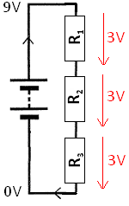
Water Slide Analogy
Imagine instead of getting a potential difference we get a height difference by reaching the top of a slide. This series circuit has three connected slides and the parallel circuit below has three separate slides that reach the bottom.

Voltages/P.D.s
In series we can see that the total height loss is equal to how much you fall on slide 1, slide 2 and slide 3 added together. This means that the total p.d. lost must be the p.d. given by the battery. If the resistors have equal values this drop in potential difference will be equal.
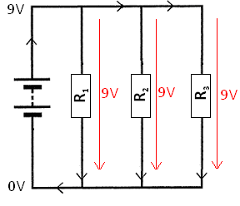
In parallel we see each slide will drop by the same height meaning the potential difference is equal to the total potential difference of the battery.

Currents
If we imagine 100 people on the water slide, in series we can see that 100 people get to the top. All 100 must go down slide 1 then slide 2 and final slide 3, there is no other option. So the current in a series circuit is the same everywhere.
In parallel we see there is a choice in the slide we take. 100 people get to the top of the slide but some may go down slide 1, some down slide 2 and some down slide 3. The total number of people is equal to the number of people going down each slide added together, and the total current is equal to the currents in each circuit/loop.
Unit 1 | Energy and Power
Lesson 17
Learning Outcomes | To know what power is and how to calculate the power of an electrical circuit
Learning Outcomes | To know how to calculate the energy transferred in an electrical circuit
Learning Outcomes | To be able to derive further equations or use a series of equations to find the answer | N. DWYER

Power (Also seen in GCSE Physics 1)
Power is a measure of how quickly something can transfer energy. Power is linked to energy by the equation:

$\text{Power}=\frac{\text{Energy}}{\text{time}}$

Power is measured in Watts, W
Energy is measured in Joules, J
Time is measured in seconds, s

New Equations
If we look at the equations from the QVIRt lesson we can derive some new equations for energy and power.
Energy
$V=\frac{E}{Q}$ can be rearranged into $E=\text{VQ}$ and we know that $Q=\text{It}$so combining these equations we get a new one to calculate the energy in an electric circuit:
$E=\text{VQ}$<----------------------$Q=\text{It}$ so $E=\text{VIt}$ (1)

Power
If we look at the top equation, to work out power we divide energy by time:
$\frac{E}{t}=\frac{\text{VIt}}{t}$ which cancels out to become $P=\text{VI}$ (2)

If we substitute$V=\text{IR}$into the last equation we get another equation for power:
$P=\text{IV}$<----------------------$V=\text{IR}$ so $P=I^{2}R$ (3)

We can also rearrange $V=\text{IR}$into $I=\frac{V}{R}$and substitute this into $P=\text{VI}$to get our last equation for power:
$P=\text{VI}$<----------------------$I=\frac{V}{R}$ so $P=\frac{V^{2}}{R}$ (4)

Energy again
Two more equations for energy can be derived from the equation at the top and equations 3 and 4
Energy = Power x time

$\text{Pt}=I^{2}\text{Rt}$ Equation 3 becomes $E=I^{2}\text{Rt}$ (5)

$\text{Pt}=\frac{V^{2}}{R}t$ Equation 4 becomes $E=\frac{V^{2}}{R}t$ (6)

Fuses (Also seen in GCSE Physics 2)
Electrical devices connected to the Mains supply by a three-pin plug have a fuse as part of their circuit. This is a thin piece of wire that melts if the current through it exceeds its maximum tolerance. The common fuses used are 3A, 5A and 13A. A 100W light bulb connected to the UK Mains would have a 240V potential difference across it. Using $P=\text{IV}$ we can see that the current would be 0.42A so a 2A fuse would be the best to use.

Applications
The starter motor of a motor car needs to transfer a lot of energy very quickly, meaning its needs a high power. Millions of Joules are required in seconds; since the voltage of the battery is unchanging we need current in the region of 160A which is enormous.
The power lines that are held by pylons and form part of the National Grid are very thick and carry electricity that has a very high voltage. Increasing the voltage lowers the current so if we look at the equation $E=I^{2}\text{Rt}$we can see that this lowers the energy transferred to the surroundings.
Unit 1 | EMF and Internal Resistance
Lesson 18
Learning Outcomes | To know what emf and internal resistance are
Learning Outcomes | To know how to measure internal resistance
Learning Outcomes | To be able sketch and interpret a V-I graph, labelling the gradient and y-intercept | N. DWYER

Energy in Circuits
In circuits there are two fundamental types of component: energy givers and energy takers.

Electromotive Force (emf), ε
Energy givers provide an electromotive force, they force electrons around the circuit which transfer energy.
The size of the emf can be calculate using: $ε=\frac{E}{Q}$
This is similar to the equation we use to find voltage/potential difference and means the energy given to each unit of charge. We can think of this as the energy given to each electron.
The emf of a supply is the p.d. across its terminals when no current flows
EMF is measured in Joules per Coulomb, JC⁻¹ or Volts, V

Energy takers have a potential difference across them, transferring energy from the circuit to the component.
emf = energy giver p.d. = energy taker
Energy is conserved in a circuit so energy in = energy out, or:
The total of the emfs = The total of the potential differences around the whole circuit

Internal Resistance, r
The chemicals inside a cell offer a resistance to the flow of current, this is the internal resistance on the cell.
Internal Resistance is measured in Ohms, Ω

Linking emf and r
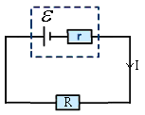If we look at the statement in the box above and apply it to the circuit below, we can reach an equation that links emf and r.
Total emfs = total potential differences
ε = (p.d. across r) + (p.d. across R) {Remember that V=IR}
ε = (I x r) + (I x R)
ε = Ir + IR
ε = I(r+R)
The terminal p.d. is the p.d. across the terminals of the cell when a current is flowing
ε = internal p.d + terminal p.d.
So the above equation can be written as ε = Ir + V where V is the terminal p.d.
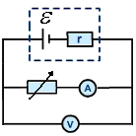

Measuring emf and r
We can measure the emf and internal resistance of a cell by measuring the current and voltage as shown on the right, the variable resistor allows us to get a range of values. If we plot the results onto a graph of voltmeter reading against ammeter reading we get a graph that looks like the one below.

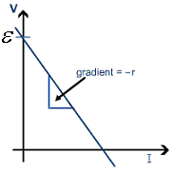Graphs have the general equation of y = mx+c, where y is the vertical (upwards) axis, x is the horizontal (across) axis, m is the gradient of the line and c is where the line intercepts (cuts) the y axis.
If we take ε = Ir + V and arrange it into y= mx + c
y axis = V and x axis = I
ε = Ir + V → V = -Ir + ε → V = -r I + ε
y =m x +c
So we can see that the:
y-intercept represents the emf
and
gradient represents (–)internal resistance
Unit 1 | Kirchhoff and Potential Dividers
Lesson 19
Learning Outcomes | To know Kirchhoff’s laws and be able to apply them to questions
Learning Outcomes | To know what a potential dividers is and be able to calculate the output voltage
Learning Outcomes | To be able to explain an application of a potential divider | N. DWYER

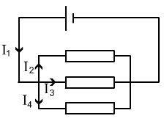
Kirchhoff’s Laws
Kirchhoff came up with two (some may say rather obvious) laws concerning conservation in electrical circuits.

Captain Obvious’ First Law
Electric charge is conserved in all circuits, all the charge that arrives at a point must leave it.
Current going in = current going out.
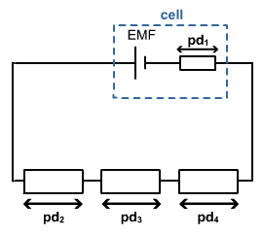In the diagram we can say that: I₁ = I₂ + I₃ + I₄

Captain Obvious’ Second Law
Energy is conserved in all circuits, for any complete circuit the sum of the emfs is equal to the sum of the potential differences.
Energy givers = energy takers.
In the diagram we can say that: ε = pd₁ + pd₂ + pd₃ + pd₄.

Potential Dividers
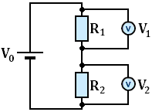
A potential divider is used to produce a desired potential difference, it can be thought of as a potential selector.
A typical potential divider consists of two or more resistors that share the emf from the battery/cell.
The p.d.s across R₁ and R₂ can be calculated using the following equations:
$V_{1}=V_{0}\frac{R_{1}}{R_{1}+R_{2}}$ $V_{2}=V_{0}\frac{R_{2}}{R_{1}+R_{2}}$

This actually shows us that the size of the potential difference is equal to the input potential multiplied by what proportion of R₁ is of the total resistance.
If R₁ is 10 Ω and R₂ is 90 Ω, R₁ contributes a tenth of the total resistance so R₁ has a tenth of the available potential. This can be represented using:
$\frac{R_{1}}{R_{2}}=\frac{V_{1}}{V_{2}}$ The ratio of the resistances is equal to the ratio of the output voltages.

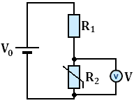
Uses
In this potential divider the second resistor is a thermistor. When the
temperature is low the resistance (R₂) is high, this makes the output voltage
high. When the temperature is high the resistance (R₂) is low, this makes the
output voltage low. A use of this would be a cooling fan that works harder
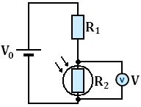
when it is warm.

In the second potential divider the second resistor is a Light Dependant Resisitor.
When the light levels are low the resistance (R₂) is high, making the output voltage
high. When the light levels increase the resistance (R₂) decreases, this makes the
output voltage decrease. A use of this could be a street light sensor that lights up
when the surrounding are dark.
Unit 1 | Alternating Current
Lesson 20
Learning Outcomes | To know what peak current/voltage is and to be able to identify it
Learning Outcomes | To know what peak-to-peak current/voltage is and to be able to identify it
Learning Outcomes | To know what r.m.s. values are and to be able to calculate them | N. DWYER

ACDC Definitions (Also seen in GCSE Physics 2)

Direct Current
Cells and batteries are suppliers of direct current; they supply an emf in one direction.
In the graph below we can see that the current and voltage are constant. The bottom line shows that when the battery or cell is reversed the voltage and current are constants in the other direction

Alternating Current
The Mains electricity supplies an alternating current; it supplies an emf that alternates from maximum in one direction to maximum in the other direction.
In the graph below we see the voltage and current start at zero, increase to a maximum in the positive direction, then fall to zero, reach a maximum in the negative direction and return to zero. This is one cycle.
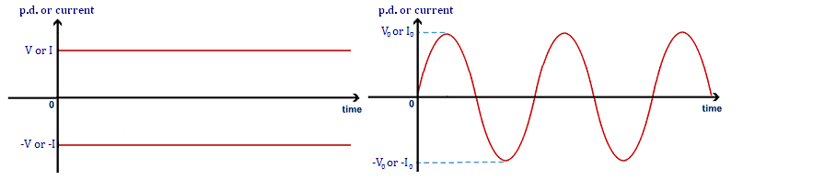

Alternating Current Definitions

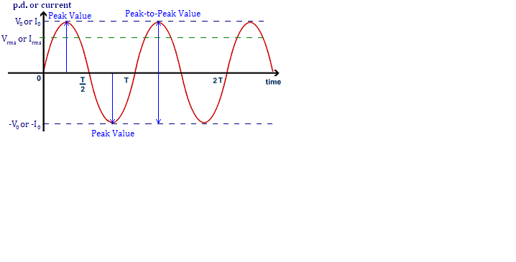
Peak Value
The peak value of either the current or the potential difference is the maximum in either direction. It can be measured from the wave as the amplitude, the distance from 0 to the top (or bottom) of the wave. We denote peak current with I₀ and peak p.d. with V₀.

Peak-to-Peak Value
The peak-to-peak value of either the current or potential difference is the range of the values. This is literally the distance from the peak above the zero line to the peak below the line.

Time Period
In an a.c. current or p.d. this is the time taken for one complete cycle (or wave).

Frequency
As with its use at GCSE, frequency is a measure of how many complete cycles that occur per second.
Frequency is measured in Hertz, Hz.

Root Mean Squared, r.m.s.
Since the current and p.d. is constantly changing it is impossible to assign them a fixed value over a period of time, the average would be zero. The r.m.s. current produces the same heating effect in a resistor as the equivalent d.c. for example 12V dc = 12Vrms ac
$I_{\text{rms}}=\frac{I_{0}}{\sqrt{2}}$ which can be rearranged to give $I_{0}=I_{\text{rms}}\sqrt{2}$

$V_{\text{rms}}=\frac{V_{0}}{\sqrt{2}}$ which can also be rearranged to give $V_{0}=V_{\text{rms}}\sqrt{2}$
Unit 1 | The Oscilloscope
Lesson 21
Learning Outcomes | To know what are the main controls of the oscilloscope
Learning Outcomes | To be able to determine the voltage and current using an oscilloscope
Learning Outcomes | To be able to determine the time period and frequency using an oscilloscope | N. DWYER

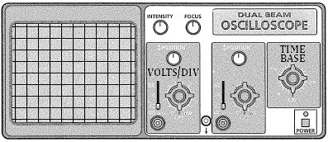
The Oscilloscope
An oscilloscope can be used to show the sizes of voltages and currents in both d.c. and a.c. circuits. This is what a typical oscilloscope looks like. A trace would be seen on the grid display.

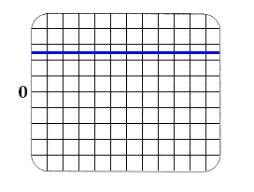
D.C. Traces (Also seen in GCSE Physics 2)
If we connected a battery or cell to an oscilloscope, we would see a trace similar to the one shown here. The current of a d.c. supply is constant, this means the voltage is constant.
We see a straight line.

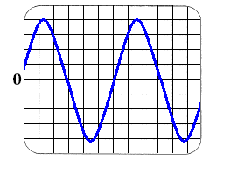
A.C. Traces (Also seen in GCSE Physics 2)
If we connect anything that draws power from the Mains to an oscilloscope we will see a similar trace to the one shown here. The current is constantly changing from maximum flow in one direction to maximum flow in the other direction; this means the voltage is doing the same.
We see a wave.

Controls
There are two main controls that we use are the volts/div and time base dials:
The volts/div (volts per division) dial allows you to change how much each vertical square is worth.
The time base dial allows you to change how much each horizontal square is worth.

Voltage
We can measure the voltage of a d.c. supply by counting the number or vertical squares from the origin to the line and then multiplying it by the volts/div. In the trace the line is 2.5 squares above 0, if each square is worth 5 volts the voltage is (2.5 x 5) 12.5 volts.
We can measure the peak voltage of an a.c. supply by counting how many vertical squares from the centre of the wave to the top and then multiplying it by the volts/div (how much voltage each square is worth). In the trace the peak voltage is 4 squares high, if each square is worth 5 volts the voltage is (4 x 5) 20 volts.

Time and Frequency
We can measure the time for one period (wave) by counting how many horizontal squares one wavelength is and then multiplying it by the time base (how much time each square is worth).
In the trace above one wave is 6 squares long, if each square is worth 0.02 seconds the time for one wave is 0.12 seconds.
We can calculate the frequency (how many waves or many times this happens per second) using the equation:
$f=\frac{1}{T}$ and $T=\frac{1}{f}$
If the time period is 0.12 seconds, the frequency is 8.33Hz
Frequency is measured in Hertz, Hz

